Compensation of Voltage Swell by Using STATCOM

Abhijit R. Singare1, Suraj Dipakrao Bagekar2, Dharati Bhaskar Raut3, Samyak Madhukar Naranje4

*1Asst. Professor Dept. of Electrical Engineering, DMIETR, Sawangi, Wardha (MH), India.*

Email: [abhijit.singare@gmail.com](mailto:abhijit.singare@gmail.com).

*2,3,4Students of Electrical Engineering, DMIETR, Sawangi, Wardha (MH), India.* Email: [sbagekar123@gmail.com](mailto:sbagekar123@gmail.com).

***Abstract- In power system, power quality is one of the important aspects as power quality problems are occurred due to occurrence of voltage swell, voltage sag, transient, harmonics distortion, etc. in the transmission line. Out of these, voltage swell has less predominantly occurred and creates severe impact on transmission line and sensitive devices connected to it. By IEEE 1159 Voltage swell is an increase in RMS voltage level from 110% to 180% of nominal voltage at power frequency for the duration of 1/2 cycle to 1 minute [1]. The voltage swell is occurred due to de-energising of large heavy loads, switching off load, lightening strokes, etc. The occurrence of voltage swell is very low but when it is occurred it creates severe impact on transmission line and connected devices. Hence it is necessary to mitigate or compensate the voltage swell to improve power quality of transmission line. The compensation of voltage swell is done by using FACTS devices (STATCOM). In this paper, the analysis of 132kv transmission line with including STATCOM and without including STATCOM is simulated in MATLAB/SIMULINK software, which shows the voltage swell is compensated and voltage profile has been improved.***

***Index terms- Static synchronous compensator (STATCOM), voltage swell, T.H.D., voltage stability.***

I. INTRODUCTION

The electrical power system is very complex network consisting number of generating station, transmission line and distribution system. In this power system, power quality is one of the most important aspect as leads to power quality problems that arises due to the wide range of disturbances in power system such as voltage swell, voltage sag, harmonics, etc. From these power quality problems voltage swell (29%) has been less predominantly occurred than voltage sag (60%), transients (8%) and interruption (3%) but when he voltage is occurs it creates severe impact on the transmission line and connected devices with amplitude range from 110% to 180% for duration of 1/2 cycle to 1 minute [2]. The voltage swell can cause damage to the system or equipment’s connected to the transmission line as well as it creates heavy current imbalance that tends to operation of circuit breaker or fuses. These effects are very expensive for the costumer and ranging from the minor quality variations to production downtime and also damage to the system and connected equipment’s. There are many different methods are available to compensate or mitigate this voltage swell problem from those method one of the common and most efficient method to compensate this voltage swell is the STATCOM (static synchronous compensator). The STATCOM is an FACTS device consisting of voltage source converter made up of IGBT/DIODE, filter, insertion transformer and capacitor. STATCOM is a most efficient and fast device to compensate the voltage swell in transmission line as soon as it occurs by controlling the active and reactive power and injecting current into the transmission line system [3]. In this paper, the 3-phase, 132 kV, 50 Hz transmission line is simulated in MATLAB/SIMULINK software and the voltage swell is created by using programmable voltage source. The FACTS device i.e. STATCOM is connected in parallel with the 132 kV transmission line systems to compensate the voltage swell created by the programmable voltage source. The voltage swell can also be created by disconnecting large heavy load from the distribution system but in this paper we used programmable voltage source to create voltage swell. At the end, the results are observe on the scope 4 connected at output at the load end, which shows that the voltage swell has been compensated and voltage profile of the transmission line has been improved.

II. OVERVIEW OF POWER QUALITY

The term power quality (P.Q.) captures major attention while studying electrical power system. The term power quality refers to maintaining sinusoidal waveforms of the bus voltage and frequency at constant required level. Power quality is simply an interaction of electrical power system with the electrical equipments. Power quality is a most important term in power system hence it will be always taken into consideration because disturbing the power quality will directly affects on the system equipment in power system.

TABLE I

|  |  |  |  |
| --- | --- | --- | --- |
| Parameter | Voltage Variation  ( % ) | Duration | Permissible Variation |
| Voltage Swell | 110%-180% | ½ Cycle To 1 Minutes | +/- 10% |

Power quality problem- The Power quality brings a wide range of disturbance such as voltage swell voltage sag, harmonics, interruptions, etc. From these the voltage swell occured nearly 29% and it will damge all the equipment connected in the line. The main causes of voltage swell are as following:

1. Suddenly disconnecting of an heavy load.

2. Lightening on transmission line.

3. Voltage transients [4].

There are some approaches to compensate the power quality problem. The solution comes to eliminates the power quality is the STATCOM which improve the stability of power system by compensating the voltage variation and their by increases the voltage stability of power system [5].

III. PRINCIPLE OF STATCOM

The static synchronous compensator (STATCOM) is a shunt connected device also known as static synchronous condenser (STATCON). The STATCOM is a member of Flexible Ac Transmission System or simply FACTS devices. The STATCOM uses power semiconductor devices such as IGBT, GTO, and MOSFET etc. and other components to control the power for improving the voltage stability of the power system. The STATCOM is used either to absorb or to generate reactive power in synchronised manner with the demand to stabilise the voltage fluctuation in transmission line.

IV. WORKING PRINCIPLE OF STATCOM

To observe the working principle of STATCOM let us look at equation of reactive power transfer. Let us consider two sources V1 and V2 connected through each other through an impedance given by, Z = R + jX Ω.

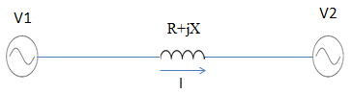

Fig.1: Block diagram of active or reactive power transfer.

Assume, the transmission line resistance R = 0 Ω, the reactive power flow,

Q= (V2/X)*[V1*cosδ-V2] … (1)

Where, δ = Aangle between V1 and V2.

For maintaining the angle δ = 0, the reactive power equation becomes,

Q= (V2/X)/[V1-V2] …(2)

The active power flow equation becomes,

P= (V1*V2*sin δ)/X=0 … (3)

Thus we can summarized that if the angle δ between V1 and V2 is zero, then the flow of active power becomes zero and reactive power is depend upon V1-V2 [5].

Thus, it can be observe that,

1. If the voltage magnitude V1 is greater than voltage magnitude V2 then reactive power will flow from source V1 to V2.

2. If the magnitude of voltage V2 is greater than V1 then power will be flow from source V2 to V1 [6].

V. DESIGN OF STATCOM

The design of STATCOM is shown below in fig.2 consists of following equipments:

1) DC capacitor: The DC capacitor is used to store the constant dc voltage through VSC after the occurrence of voltage swell & also to supply constant dc supply to voltage source convertor (VSC) at the time of voltage sag.

2) Voltage source convertor (VSC): The voltage source convertor used to work as a rectifier; it consists of IGBT power electronics devices. When the voltage swell is occurred it converts 3-ph Ac into dc voltage and the amount of voltage swell has been stored in the capacitor.

3) Harmonic filter: The harmonic filter made up of inductor to attenuate the harmonics and other high frequency components due to VSC.

4) Insertion Transformer: As the STATCOM is shunt connected device, it inject the current into the system to control the voltage regulation. The insertion transformer is connected after the VSC and harmonic filter. The insertion transformer basically acts as a coupling medium between transmission line and STATCOM. The addition work of insertion transformer is to neutralized harmonics contained in square wave produced by VSC[6]. 

Fig.2: Block diagram of transmission line with STATCOM.

VI. STATCOM AS A VOLTAGE COMPENSATOR

From the Fig.1, Voltage V1 represents voltage of STATCOM. In case of reactive power demand increases in power STATCOM increases its output voltage V1, while maintain the phase difference between V1 and V2 to zero. As, V1 > V2 reactive power will flow from STATCOM to transmission line. Thus STATCOM supplies reactive power and acts as a reactive power generator. Again, if voltage of the transmission line increases due to disconnecting of the large load, STATCOM will reduce its output voltage V1 and thus it will absorb reactive power to stabilize the voltage to normal value [7].

VII. VOLTAGE SOURCE CONVERTER (UNIVERSAL BRIDGE)

The three phase voltage source converter in Simulink form is made up of 6 IGBT thyristor. At the primary side of three phase transformer (delta-delta) the three phase AC supply is given. It consists of 6 controllable thyrister Cathode of D2, D4 & D6 are connected in +ve terminal of the capacitor while anode of D1, D3, and D5 are connected in -ve terminal of the capacitor. It can be seen that each of the secondary terminal are connected to anode of one thyristor and cathode of other thyristor. Thyristor D2, D4, D6 are conducted in +ve half cycle while the firing angle α is given to the thyristors D1, D3, D5 are conducted in -ve half cycle when the firing angle is given, at that time it produce +ve output. Thus the thyristor D1 and D4 are connected in phase 'A' while D3 and D6 are connected in phase 'B' as D5 and D2 are connected in phase 'C'. So D1 and D4 are of 60o phase shift and D3 and D6 are also 60o phase shift while D5 and D6 are also 60o phase shift. As the thyristor D1 and D4 are in same phase but do not conduct at the same time because phase have +ve and -ve peaks at the same time. Initially D6 are conducted when the firing angle α is given at an angle of ωt = 60o so output voltage is of Vab, at the time of D1 & D6 is ON. Then at ωt = 120o D1 is trigger so thyristor D1 & D2 are conducted and get output is Vac. now at ωt = 180' thyristor D2 are triggered and D3 & D2 are conduct and produce Vbc output.at the angle of ωt=240o D3 are trigger and D3 & D4 conduct at the same. At the angle ωt=300o firing angle is given the thyrister D4 and conduct the thyristor D5 & D4 and gives the output Vca. At an angle of 360o thyristor D5 are firing and conduct D5 & D6 at the same time. In this way this can be repeat.

VIII. SINUSOIDAL PULSE WIDTH MODULATION

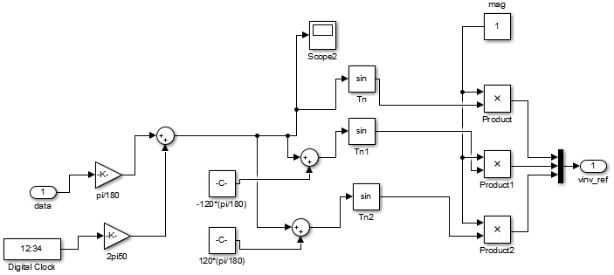

Fig.3: Sinusoidal PWM based control system.

The main objective of the control scheme is to maintain the constant voltage magnitude. This control system measures only the actual voltage at the load point with help of VI measurement block. The VSC switching technique is based on the sinusoidal pulse width modulation (SPWM). The PI controller is to identify the error signal and generates the required angle δ to obtain error to zero, the actual voltage of transmission line brought back to the reference voltage i.e. at comparator block. In SPWM technique to generate PWM signals three sinewaves and high frequency triangular carrier waves are used. The sinusoidal waves are used for voltage source convertor. The sinusoidal waves are used in SPWM are known as reference signal and they have a 120o phase shift with each other. Base on required convertor output frequency (50Hz). The frequency of these sinusoidal waves has been chosen. The carrier triangular wave having a several kHz frequency. By comparing the sinusoidal waves with the triangular wave the switching signals are generated. The comparator generates the pulses when the sinusoidal voltage is greater than the triangular voltage and this pulse is used to trigger the respective bridge convertor’s IGBT switches. The switches of any leg cannot switch off simultaneously and the outputs of phases are mutually phase shifted by 1200 [3].

IX. PI CONTROLLER

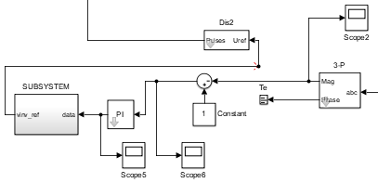

Fig.4: PI controller based on phase control method

The proportional integral (PI) controller is needed for non-integrating process, means any process that eventually return to the same output given the same set of input and disturbance. The purpose of the PI controller is to identify the error signal and generates the required and δ to run the error to zero, the load rms voltage (actual voltage) brought back to the reference voltage. This method is called as phase control method [7] shown above in fig.4. Then this error angle signal is given to the SPWM controller and accordingly error angle is generated by the pulse generator and given to the universal bridge of STATCOM. Then STATCOM is come into operation and inject the current into transmission line to compensate the voltage.

X. SIMULATION WITHOUT STATCOM

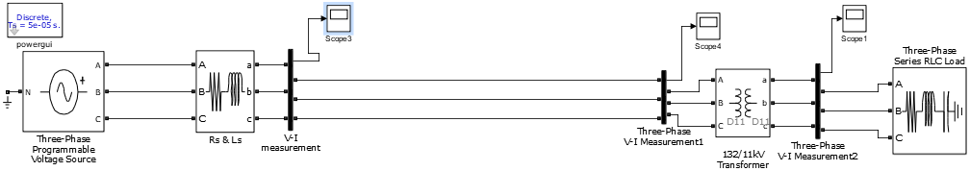

Fig.5: Simulation of 132kV transmission line without STACOM

The fig. 5 shows the simulation model of 132 kV transmission line without including STATCOM. It contain the following components,

i) Programmable voltage source: the programmable voltage source is act as a voltage source of 132 kV, the main aim of the programmable voltage source is to supply the 132kV voltage to the system and also create the swell of 1.2 p.u. for duration of 0.1 to 0.4 second which is done by the simple programming.

ii) Rs & Ls: These are the transmission line resistance and inductance it kept at negligible value.

iii) Step-down transformer: It is a distribution transformer used to step down 132 kV transmission line voltage 11 kV.

iv) Industrial Load: The 11kV industry is a load for 11kV supply.

v) VI measurement and scopes: The VI measurement blocks are used to measure the voltage in p. u. form.

The voltage swell of 1.2 p.u. for 0.1 to 0.4 second is created by using programmable voltage source and this voltage swell is travel along the line until it will be compensated.

XI. SIMULATION WITH STATCOM

The fig. 6 shows the simulation model of “Compensation of Voltage Swell by using STATCOM", the STATCOM is connected to 132kV transmission line. In the simulation model voltage is represented in per unit (p.u.) form i.e. 132kV=1p.u. The actual voltage of transmission line is sense by V-I measurement and the waveform is shown in fig.7 which show the voltage swell of 1.2 p.u. The actual magnitude of voltage (p.u.) is given to the 3-phase sequence analyser circuit block which used to represent the 3-phase voltage Va, Vb & Vc in the reference voltage respectively. The phase terminal of the block is terminated by terminator block and only actual voltage (p.u.) signal is fed to the comparator. In the comparator actual voltage signal is compared with the reference voltage signal and it generates the error signal. In the next stage the PI controller will process this error signal and the output is the angle, which is provided to the SPWM generator, this method from 3-phase sequence analyser block to the pulse generator is known as phase control method. In SPWM generator, according to the error angle δ the pulse generator generates the firing pulses and applied to the universal bridge and acts a rectifier. Thus the amount of voltage swell occur in transmission line is store in the capacitor which is connected to the STATCOM. Thus in this way STATCOM compensate the voltage swell.

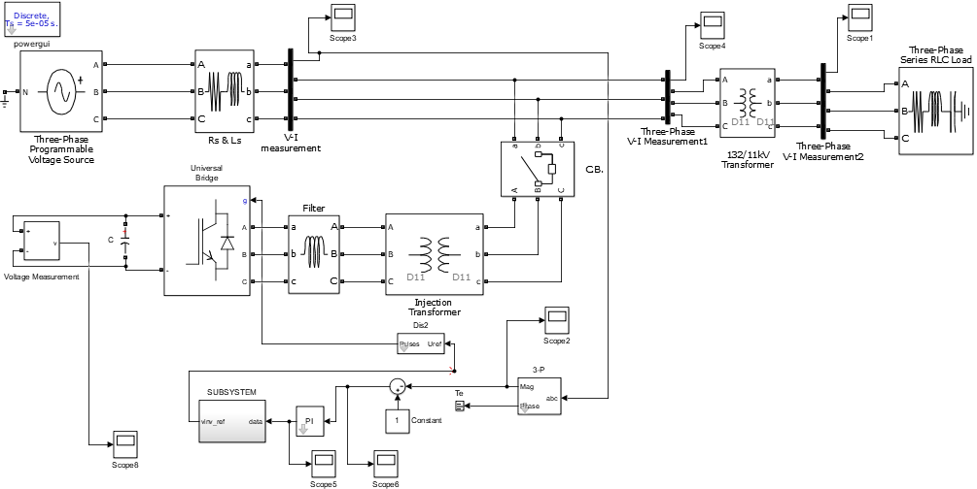

Fig.6: Simulation of 132kV transmission line with STACOM

XII. RESULT AND WAVEFORM

The basic transmission line model having rating of 3-phase, 132kV, 50 Hz. The 132 kV transmission line voltages is stepped down to 11kV by using distribution transformer and given to 11kV industrial load. The STATCOM is connected in parallel to transmission line to compensate the voltage swell is shown in fig.5, the voltage swell of 1.2 p.u. is created by using programmable voltage source for the duration of 0.1 to 0.4 second.

The fig.7 show the waveform of voltage swell of 1.2 p.u. on 132kv transmission line.

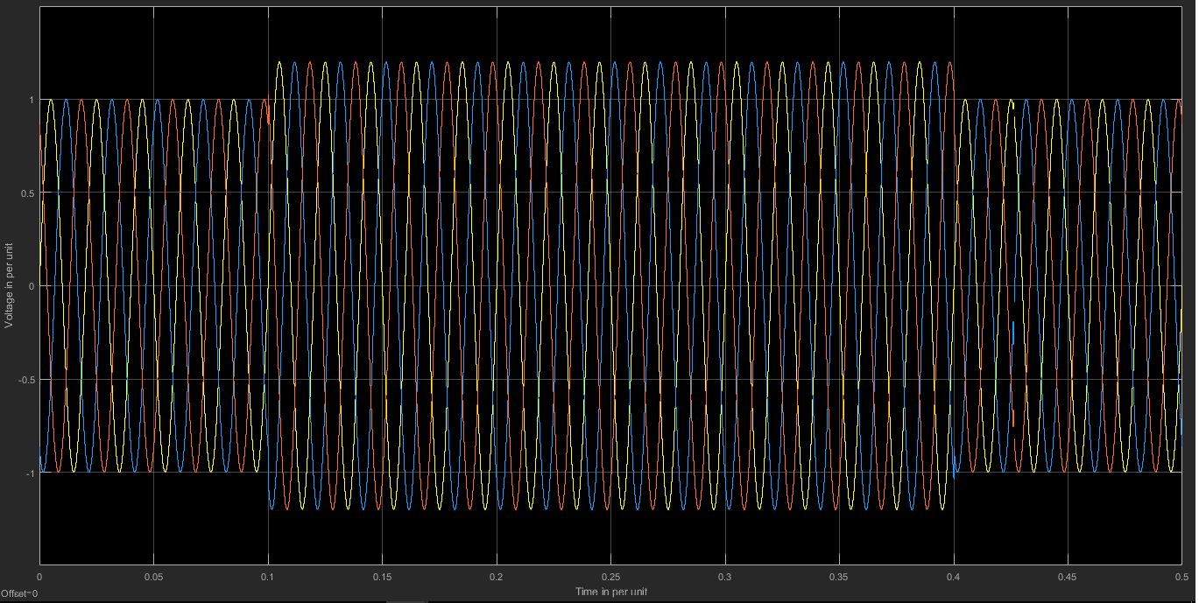

Fig.7. Waveform of voltage swell on 132 transmission line

To compensate the voltage swell the STATCOM is connected in shunt with the transmission line and it mitigates the voltage swell effectively. The waveform for compensation of voltage swell by using STATCOM is show below in fig.8.

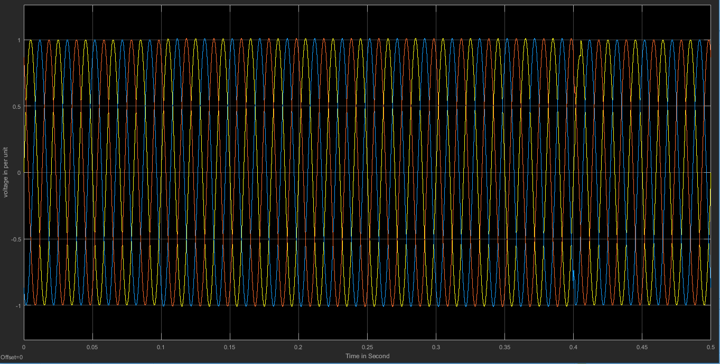

Fig.8. Waveform of compensation of voltage swell by using STATCOM

The STATCOM is very efficient device to improve the voltage stability by compensating the voltage swell.

The waveform of PI controller is shown below in fig.9

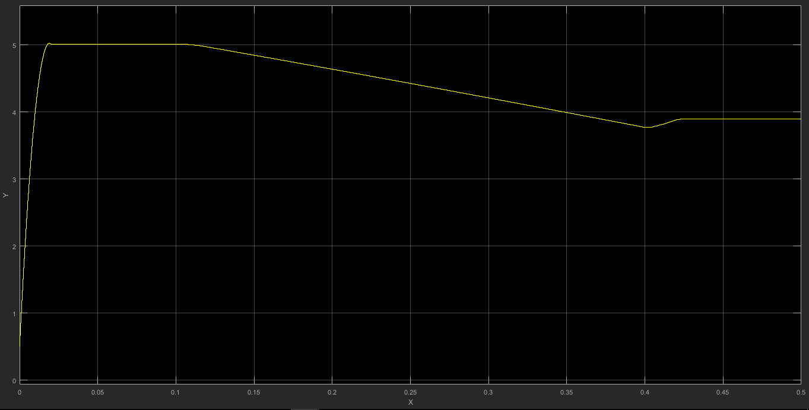

Fig.9. Waveform of PI controller

The waveform of capacitor voltage during period of compensation of voltage swell is shown below in fig.10.

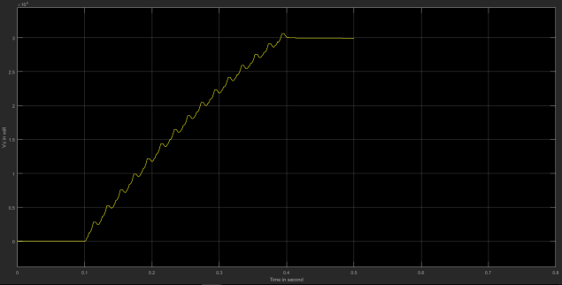

Fig.10. Waveform of voltage across capacitor during compensation of voltage swell by using STATCOM

XIII. CONCLUSION

This paper present, compensation of voltage swell by using STATCOM which has been develop with 3-phase, 132kV, 50 Hz transmission line with all necessary components and control system. The scheme has been demonstrated on MATLAB / SIMULINK software. The voltage swell of 120% i.e. 1.2 p.u. is created by using programmable voltage source and this voltage swell is compensated by using STATCOM. Hence, it can be conclude that the STATCOM is an effective device to improve the power quality by compensating the voltage swell.

XIV. REFERENCE PAPERS

[1] Reza Sedaghati, Navid Mehdizadeh Afroozi, Yaser Nemati, Ahmad Rohani, Ali Reza Toorani,

Navid Javidtash6, Ali Heydarzadegan and Hossein Sedaghati, “A survey of Voltage Sag and Voltage Swell Phenomena in Power Quality Problems”, International Journal of scientific research and management (IJSRM) Vol. (1), Issue (9),Pages 458-462, 2013.

[2] David Viroganti, Cholleti Sriram, “Implementation of SPWM technique in D-STATCOM for Voltage Sag and Swell” International Electrical Engineering Journal (IEEJ) Vol. 5 (2015) No.12, pp. 1649-1654 ISSN 2078-2365.

[3] Ahmed Majed, Zainal Salam, “Multilevel D-STATCOM for Sag and Swell Mitigation Using Modulation Index Control 978-1-4799-8598-2/15, IEEE 2015.

[4] BOOKS N. G. Hingorani, L. Gyugyi, Understanding FACTS, Concepts and Technology of Flexible AC Transmission systems, IEEE Press 2000.

[5] Rajiv Kumar Chauhan and J.P. Pandey “Mitigation of Power Quality Problems Using FATCS Devices: A Review” International Journal of Electronic and Electrical Engineering, volume 7, Number 3 (2014) International Research Publication House.

[6] STATCOM-Working Principle, Design and Application| ETRICAL, <http://etrical.blogspot.com>.

[7] Manbir Kaur, Prince J. Indal,“D-STATCOM FOR VOLTAGE SAG, VOLTAGE SWELL MITIGATION USING SIMULINK” International Journal of Advance Technology in Engineering and Science Volume No. 03, Special Issue No. 02, February 2015.